**Topic – SQL Task-1**

a) Get First_Name from employee table using alias name “Employee Name”.

Ans :

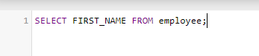

Output:

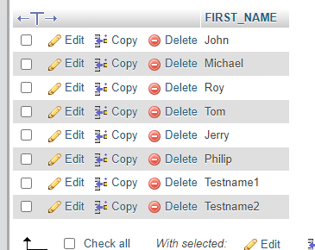

b) Get FIRST_NAME, Joining year, Joining Month and Joining Date from employee table.

Ans :

Query:

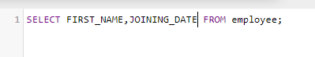

Output :

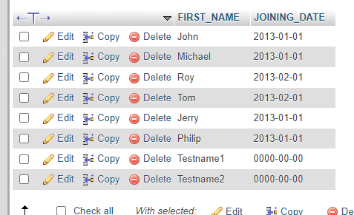

c) Get all employee details from the employee table order by First Name Ascending And Salary descending?

Ans :

Code : First Name Ascending



O/P:

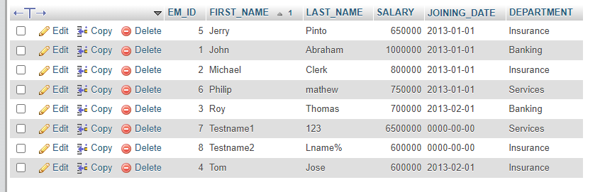

Code : Salary descending



O/P

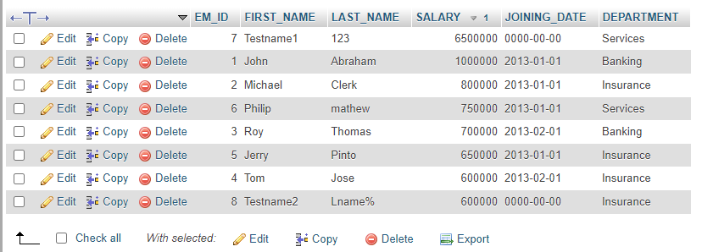

d) Get employee details from employee table whose first name contains „o‟.

Ans :

Query:

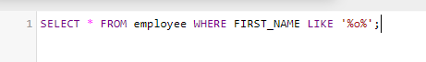

O/P:

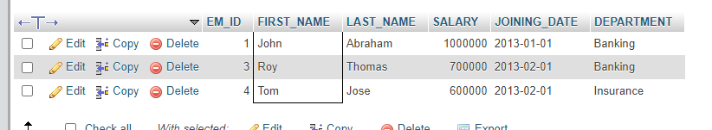

e) Get employee details from employee table whose joining month is “January”.

Ans :

Query :



O/P:

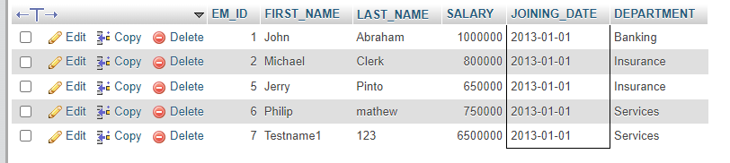

f) Get department, total salary with respect to a department from employee table

Order By total salary descending.

Ans :



O/P:

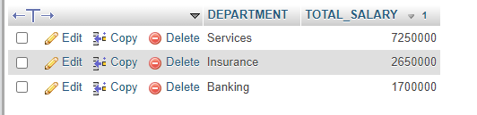

g) Get department wise maximum salary from employee table order by salary ascending?

Ans :



O/P:

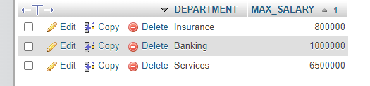

h) Select first_name, incentive amount from employee and incentives table for those Employees who have incentives and incentive amount greater than 3000?

Ans :

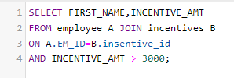

O/P:

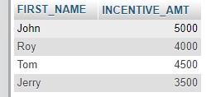

i) Select 2nd Highest salary from employee table.

Ans :



O/P

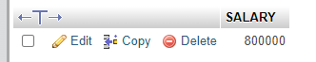

j) Select first_name, incentive amount from employee and incentives table for all Employees who got incentives using left join.

Ans :

Query:

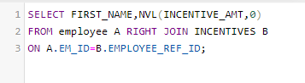

O/P:

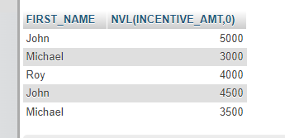

k) Create View OF Employee table in which store first name, last name and salary only.

Ans :

Query:



O/P:

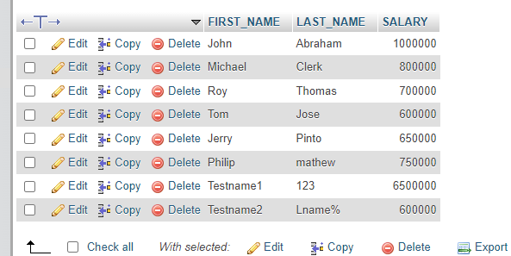

l) Create Procedure to find out department wise highest salary.

Ans :

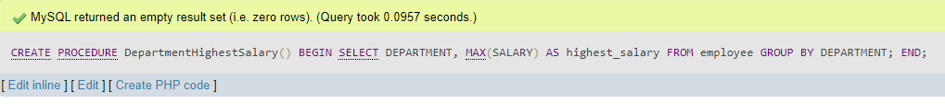

m) Create after Insert trigger on Employee table which insert records in view table.

Ans :

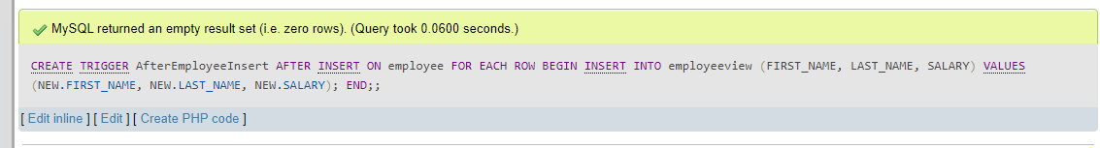

**Task-2:**

a) All orders for more than $1000.

Ans :

Query:

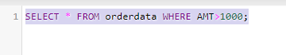

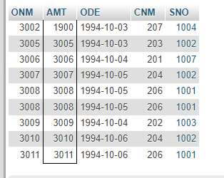

b) Names and cities of all salespeople in London with commission above 0.10.

Ans :

Query:



O/P;

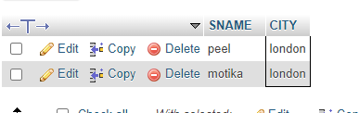

c) All salespeople either in Barcelona or in London.

Ans:

Query :



O/P:

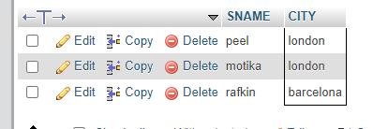

d) All salespeople with commission between 0.10 and 0.12. (Boundary values should be excluded).

Ans :

Query



O/P

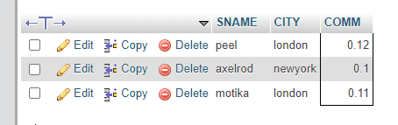

e) All customers with NULL values in city column.

Ans :



f) All orders taken on Oct 3Rd and Oct 4th 1994.

Ans :

Query:



O/P

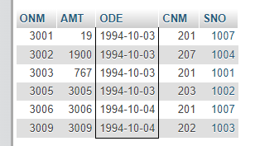

g) All customers serviced by peel or Motika.

Ans :

Query:



O/P

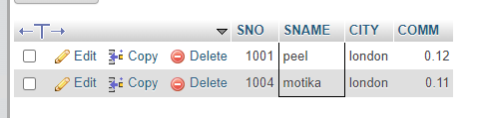

h) All customers whose names begin with a letter from A to B

Ans:

Query

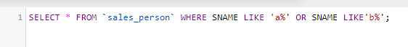

O/P

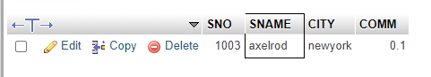

i) All customers excluding those with rating <= 100 unless they are located in Rome.

Ans :

Query



O/P

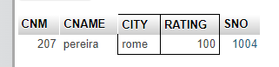

j) All orders except those with 0 or NULL value in amt field.

Ans :

Query



O/P

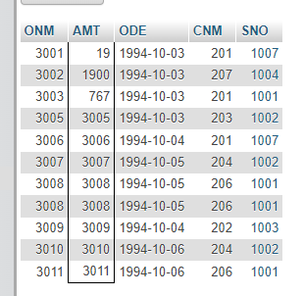

k) Count the number of salespeople currently listing orders in the order table.

Ans :

Query



O/P

